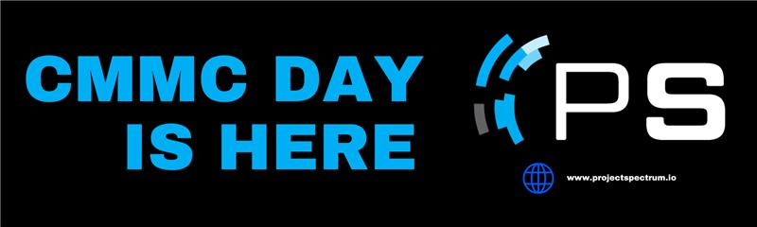

**CMMC Takes Effect Today - Here is What You Need to Know!**

The CMMC Program Rule (32 CFR Part 170) takes effect today, December 16, 2024. DoD contractors and subcontractors must now comply with formalized cybersecurity requirements to protect Federal Contract Information (FCI) and Controlled Unclassified Information (CUI) based on their risk profile.

**What Contractors and Subcontractors Need to Do Now**

DoD contractors subject to CMMC requirements are recommended to establish/re-establish relationships with DoD Contracting Officers and Program Office personnel. Subcontractors subject to CMMC requirements are recommended to contact their prime contractor knowledgeable on CMMC requirements, including legal departments.

1. **Evaluate and confirm your in-scope environment**in light of the published [Scoping Guidance](https://4icej.r.sp1-brevo.net/mk/cl/f/sh/SMK1E8tHeFuBm0ElivgcfedxSLcw/geY7iGITMH34) to ensure the SSP covers all in-scope system components, locations, personnel, and service providers.
2. **Review all responsibility matrices** for all service providers and ensure they are clear and detailed.
3. **Review every applicable Assessment Objective** in the corresponding [CMMC Assessment Guide](https://4icej.r.sp1-brevo.net/mk/cl/f/sh/SMK1E8tHeG13E93iu5q6lTwhQeDC/FcVUe0BV0iEI) to ensure they are all covered and fully documented in your SSP, and that all referenced supporting documentation exists and is up to date. The Assessment Objectives are used to conduct CMMC assessments and were taken from [NIST SP 800-171A](https://4icej.r.sp1-brevo.net/mk/cl/f/sh/SMK1E8tHeG7ugHsg5FzarJFROwnS/RmgEL9InIEhX).
4. **Assess your in-scope environment**to ensure that all controls described in the SSP are fully in place – and can be proven that they are in place.
5. **Establish or update accounts as applicable**in the [Supplier Performance Risk System](https://4icej.r.sp1-brevo.net/mk/cl/f/sh/SMK1E8tHeGEm8QhdGQ94x8YBNFNi/WhXRJwlYDdJ2) (SPRS) and/or [Enterprise Mission Assurance Support Service](https://4icej.r.sp1-brevo.net/mk/cl/f/sh/SMK1E8tHeGLdaZWaRaIZ2xqvLXxy/tBlTwnRUH6jo) (eMASS) systems to ensure your organization’s contact information is correct.

To get DoD Office of Small Business Programs endorsed, free CMMC compliance advisement, visit projectspectrum.io. Access an all-inclusive learning platform that provides no-cost resources, tools, and training materials and videos about cybersecurity best practices.

Public Affairs Inquiries: [sara.voigt@eccalon.com](mailto:sara.voigt@eccalon.com)

Sara Voigt, Project Spectrum Public Affairs